**Memo**

To: Professor Pisano

From: Ben Brewer, Ib Chand, Alex Prior, Allen Zou

Team: NoiseHub Team 8

Date: 04/07/2022

Subject: Final Prototype Test Plan

1. **Required Materials**

**Hardware:**

* Sensor Suite #1
  + Raspberry Pi 4B
  + Garmin LIDAR-Lite v4 x2
  + 10k Thermistor
  + Pi Case
  + Breadboard Case
  + Circuitry components
* Sensor Suite #2
  + Raspberry Pi 4B
  + Adafruit USB Microphone
  + Pi Case
* Laptop
  + Pi SSH
  + Mobile App iOS simulator
  + AWS Dashboard

**Software:**

* Python Scripts:
  + Sensor suite scripts
* Amazon Web Services (Backend)
  + AWS Cognito
  + AWS DynamoDB
  + AWS Amplify
  + AWS AppSync
  + AWS TimeStream
  + AWS Lambda
* React Native Mobile Application

**2.0 Test Setup**

Both Raspberry Pis will be turned on and connected to BU’s network. Next, the team will ensure the Lidar and thermistor are properly wired. Then, the team will SSH into both Pi’s to display real-time data and observe changes in room conditions. A member of the team will also log into AWS to view the DynamoDB tables and Timestream as data is transmitted. Finally, a member of the team will launch the mobile app in an iOS simulator.

**3.0 Test Procedure**

1. Open mobile application to view current room conditions
2. Demonstrate Lidar trip point system
   1. Two members will walk in and out multiple times
   2. The specific number being reported can be viewed through AWS Timestream and the Pi console out while SSH’ed
3. Trip the Lidar multiple times in each direction to show mobile app reported occupancy changing
4. Submit user check in to demonstrate the reported room occupancy changing on mobile app
   1. View correction variable updating in DynamoDB/console
   2. Send a “high” user feedback and verify that the graph data for headcount moves up
   3. Send a “low” user feedback and verify that the graph data for headcount moves down
   4. If max headcount changes due to feedback, verify that the change is reflected in the graph
5. Speak louder and quieter near the microphone to show mobile app reported volume changing
6. Hold the thermistor in one members hand to show mobile app reported temperature changing
7. Show data of last 24 hours in DynamoDB

**4.0 Measurable Criteria**

**Headcount Testing**

| Test | Entrances | Exits | Mobile App Display |
| --- | --- | --- | --- |
| Results |  |  |  |

Volume Testing

| Test | High Volume | Medium Volume | Low Volume | Mobile App Display |
| --- | --- | --- | --- | --- |
| Results |  |  |  |  |

Temperature Testing

| Test | Increased Temperature | Lowered Temperature | Mobile App Display |
| --- | --- | --- | --- |
| Results |  |  |  |

User Feedback Testing

| Test | Reported Low Headcount | Reported High Headcount |
| --- | --- | --- |
| Mobile App updates on relaunch |  |  |

**5.0 Hardware Pinout**

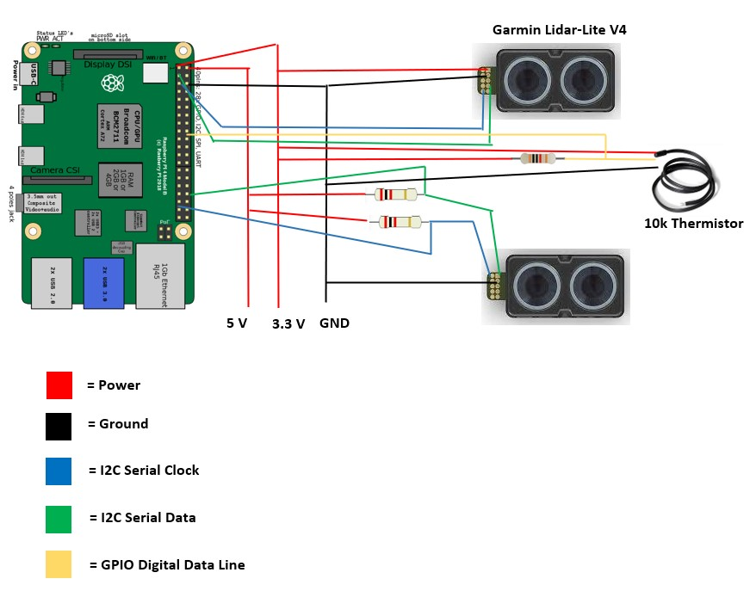

*Circuit of sensor suite #1 with Lidar trip system and 10k thermistor. Sensor suite #2 is only Pi with USB mic plugged in*